

CAPSTONE PROJECT REPORT
Report 3 – Software Requirement Specification

Pactkeeper - Tactical Strategy Role-Playing Game System

Name | Student ID | Role
Nguyễn Bách Hiệp | SE192114 | Team Leader
Lê Vũ Văn | SE190612 | Team Member
Lê Nguyễn Tuấn Khoa | SE194755 | Team Member
Võ Hoàng Thắng | SE182121 | Team Member
Lê Cao Khánh Hoàng | SE192527 | Team Member
Supervisor: Phạm Thanh Trí

– Ho Chi Minh, October 2026 –
Table of Contents
I. Project Report 3
1. Status Report 3
2. Team Involvements 3
3. Issues/Suggestions 3
II. Software Requirement Specification 4
1. Overall Description 4
1.1 Product Overview 4
1.2 Business Rules 5
2. User Requirements 6
2.1 System Actors 6
2.2 Use Cases 6
3. Functional Requirements 8
3.1 System Functional Overview 8
3.2 <<Feature Name 1>> 10
3.3 <<Feature Name 2>> 10
4. Non-Functional Requirements 11
4.1 External Interfaces 11
4.2 Quality Attributes 12
5. Other Requirements 14
5.1 Appendix1 - Messages List 14
5.2 Appendix2 - … 14
5.3 … 14

I. Record of Changes
Date | A*  M, D | In charge | Change Description
*A - Added M - Modified D - Deleted

II. Software Requirement Specification

1. Product Overview
The Context Diagram describes the highest-level boundary and interactions of the PactKeeper System with its external environment. The primary actor is the Player, who performs core functions such as login, in-match actions, team/character configuration, and gacha, matchmaking, and story requests. Players can also invite friends to play together, receive invite notifications, and accept or decline invitations. On the internal operations side, the system separates three roles: the Admin manages user accounts and views dashboard data; the Mod configures game content (reward, gacha, story, and item settings) and monitors match logs and team information; and Technical Support handles system configuration, statistics requests, and monitoring of logs, alerts, and system/server status. In addition, the system communicates with two third-party services: Google OAuth for login authentication, and PayOS for in-game payment processing.
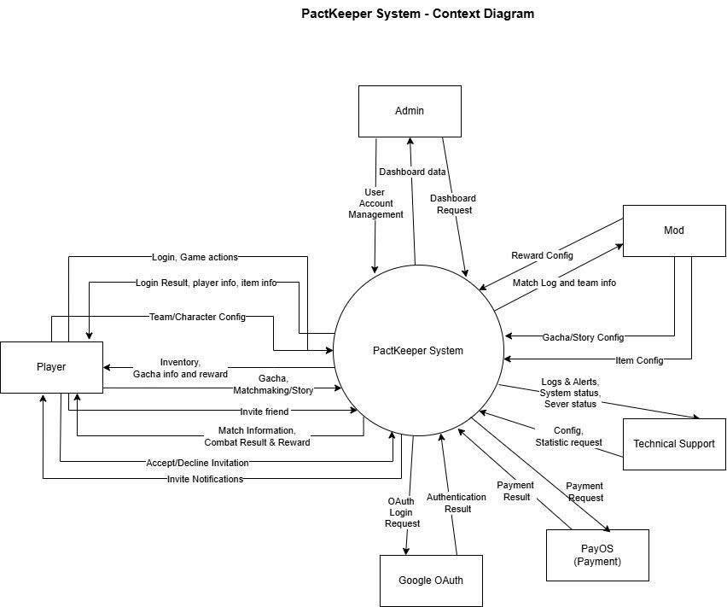

2. User Requirements

2.1 Actors
# | Actor | Description
1 | Player | The main user interacts with the game's core features.
2 | Admin | Administrator who manages user accounts and views the dashboard.
3 | Technical Support | Staff responsible for configuring the system, monitoring status, and viewing logs.
4 | Mod | Moderator who configures gacha/rewards and inspects PvP matches.
5 | Authenticated | A logged-in user (this is the parent Actor for Admin, Technical Support, and Mod).
6 | Google OAuth | An external system that handles authentication.
7 | PayOS | An external system that processes payments.

2.2 Use Cases

2.2.1 Diagram(s)
For Player: Invite Friend to Match, View Match Result, View Profile / Inventory, Manage Team Formation, Configure Unit, Pull Gacha, Buy Item from Shop, Join Random Matchmaking Queue, View Match History, Play Story Mode, Respond to Invite, Purchase Gems.
For Admin: Manage User Accounts, View Admin Dashboard.
For Technical Support: Configure System, Statistic Request, Monitor System Status, View Logs & Alerts.
For Mod: Item/Combat Reward Config, Gacha/Story Config, Inspect PvP Match.
For Authenticated User: Login.
System Processing Use Cases: UC24 Authenticate & Issue Token, UC25 Process Payment, UC26 Play PvP Match, UC27 Calculate Match Reward, UC28 Record Match Result, UC29 Log Match Actions (realtime, per action), UC30 Persist Gacha & Story Configuration, UC31 Persist Shop & Reward Configuration, View Player Team Formation, View Match Action Log.

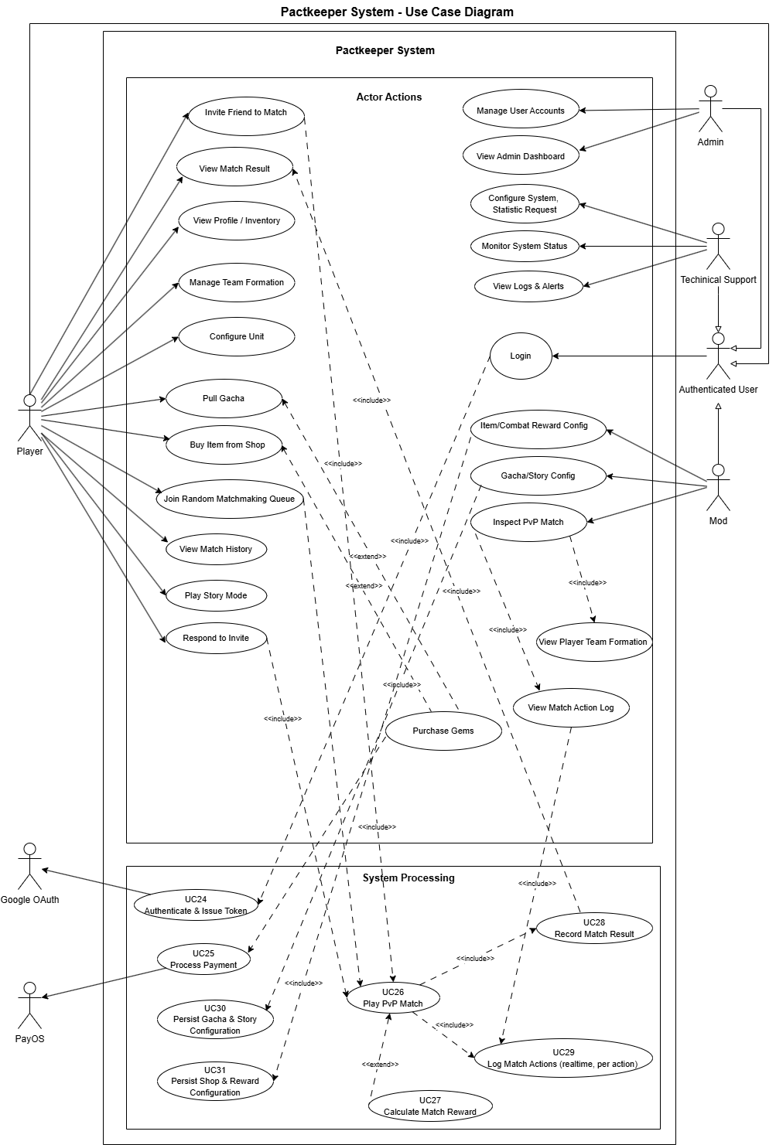

2.2.2 Descriptions
ID | Use Case | Actors | Use Case Description
01 | Invite Friend to Match | Player | Allows a player to send a game invitation to someone on their friend list.
02 | View Match Result | Player | Allows a player to see the final outcome and statistics of a completed match.
03 | View Profile / Inventory | Player | Allows a player to view their personal account details and in-game items.
04 | Manage Team Formation | Player | Allows a player to organize and set up their character lineup for battles.
05 | Configure Unit | Player | Allows a player to upgrade, equip, or modify individual game units/characters.
06 | Pull Gacha | Player | Allows a player to spend currency to randomly draw characters or items.
07 | Buy Item from Shop | Player | Allows a player to purchase in-game items using their currency.
08 | Join Random Matchmaking Queue | Player | Allows a player to enter a queue to be matched with a random opponent for PvP.
09 | View Match History | Player | Allows a player to review a list of their previously played matches.
10 | Play Story Mode | Player | Allows a player to participate in the PvE story-driven campaign.
11 | Respond to Invite | Player | Allows a player to accept or decline a match invitation from another player.
12 | Purchase Gems | Player | Allows a player to initiate a transaction to buy premium currency (Gems).
13 | Manage User Accounts | Admin | Allows an administrator to view, edit, ban, or manage player and staff accounts.
14 | View Admin Dashboard | Admin | Allows an administrator to view high-level metrics and system overviews.
15 | Configure System, Statistic Request | Technical Support | Allows tech support to adjust system parameters and request specific data reports.
16 | Monitor System Status | Technical Support | Allows tech support to observe server health, uptime, and performance metrics.
17 | View Logs & Alerts | Technical Support | Allows tech support to read system error logs and operational alerts.
18 | Item/Combat Reward Config | Mod | Allows a moderator to adjust the drop rates and rewards for matches and items.
19 | Gacha/Story Config | Mod | Allows a moderator to configure gacha banners, rates, and story mode parameters.
20 | Inspect PvP Match | Mod | Allows a moderator to review specific PvP matches for rule violations or bugs.
21 | Login | Authenticated User | Allows registered users (Admin, Mod, Tech Support) to access their respective portals.
22 | Authenticate & Issue Token | Google OAuth | The external system authenticates the user's Google credentials and provides an access token.
23 | Process Payment | PayOS | The external payment gateway handles the financial transaction for purchasing Gems.
24 | Play PvP Match | System | The core system process that handles the logic and state of a Player vs Player match.
25 | Calculate Match Reward | System | The system calculates the experience, currency, or items awarded after a match finishes.
26 | Record Match Result | System | The system saves the final outcome and statistics of a match to the database.
27 | Log Match Actions (realtime, per action) | System | The system continuously records every move made by players during an active match.
28 | Persist Gacha & Story Configuration | System | The system saves the moderator's changes to the gacha and story settings into the database.
29 | Persist Shop & Reward Configuration | System | The system saves the moderator's changes to shop prices and rewards into the database.
30 | View Player Team Formation | System | A sub-process used to retrieve and display the units a player has selected for a match.
31 | View Match Action Log | System | A sub-process used to retrieve the detailed step-by-step history of a specific match.

3. Functional Requirements

3.1 System Functional Overview

3.1.1 Screens Flow
- Game Client Screen Flow: Link
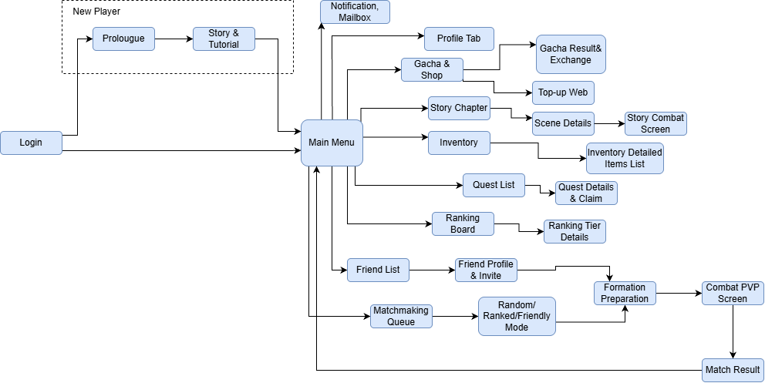
- Web Management Portals Screen Flow: Link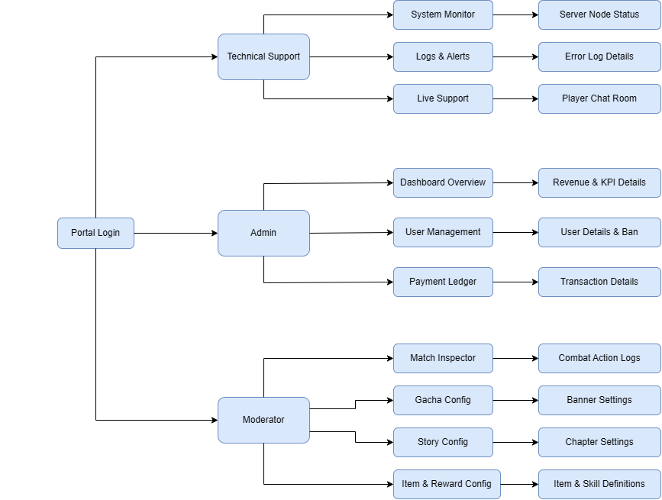

3.1.2 Screen Descriptions
Part A: Game Client Screens Flow
# | Feature | Screen | Description
1 | Authentication | Login | The primary entrypoint of the application. Allows players to authenticate via Google OAuth2, or Developer login. Validates credentials against the backend API and receives an authoritative JWT session token. Directs new players to Prologue and returns players directly to Main Menu.
2 | New Player Onboarding | Prolougue | Introductory visual novel cutscene triggered exclusively for first-time registered players. Displays world lore, background story context, and dialogue sequences that establish the game's premise before introducing gameplay.
3 | New Player Onboarding | Story & Tutorial | Interactive guided tutorial battle directly following Prologue. Guides new players through tactical tile grid navigation, Charge Time (CT) timeline mechanics, skill casting, and turn resolution. Automatically awards starter units and transitions to Main Menu upon completion.
4 | Common / Hub | Main Menu | The central dashboard and primary navigation hub of the game. Displays player level, avatar, currency balances (Gems, Gold), and energy stamina. Houses direct navigation links to all sub-features (Mailbox, Profile, Gacha, Story, Inventory, Quests, Rankings, Friends, and Matchmaking Queue).
5 | Social & Communication | Notification, Mailbox | System mail and announcement inbox accessible from Main Menu. Displays server alerts, event notifications, and developer compensation gifts. Allows players to view message details and claim attached items (Gems, Gold, Tickets) individually or via 'Claim All'.
6 | Player Profile & Settings | Profile Tab | Personal account overview displaying unique UID, registration timestamp, PvP win/loss statistics, and competitive tier. Also hosts client configuration settings including audio sliders (BGM, SFX), dynamic language toggling (English / Vietnamese), and session logout controls.
7 | Economy & Monetization | Gacha & Shop | Commercial hub displaying active character/weapon summoning banners and in-game shop catalogs. Displays drop rates, banner expiry countdowns, and pity thresholds. Serves as the navigation gateway to Gacha Result & Exchange and Top-up Web.
8 | Economy & Monetization | Gacha Result & Exchange (Gacha Result & Exchange) | Post-summon outcome screen displaying animated card reveals for pulled heroes or gear. Highlights high-rarity results, automatically converts duplicate units into breakthrough compensation materials (BR-06), and provides a pity token exchange shop.
9 | Payment Gateway | Top-up Web | Real-money Gem purchasing portal integrated with PayOS. Displays tier packages with VND pricing, initiates checkout via backend API to generate dynamic VietQR payment codes, and polls transaction fulfillment before updating player Gem balances.
10 | PvE Campaign | Story Chapter | World campaign map listing sequential story chapters, completion star ratings, and progression gates. Selecting a chapter displays its constituent story nodes and stage requirements in Scene Details.
11 | PvE Campaign | Scene Details | Stage inspection modal showing enemy formations, recommended combat power, stamina entry cost, and potential item drops. Provides the 'Start Battle' action that loads the Story Combat Screen.
12 | PvE Tactical Combat | Story Combat Screen | Tactical grid battle arena for campaign progression. The player controls their deployed team against server-side/client-side AI opponents using turn-based Charge Time (CT) timeline actions to achieve chapter victory.
13 | Asset Management | Inventory | High-level warehouse overview showing owned heroes, weapons, accessories, and consumables. Serves as the navigation gateway to the detailed filterable items list.
14 | Asset Management | Inventory Detailed Items List | Filterable tabular inventory categorized by Weapons, Trinkets, Consumables, and Enhancement Materials. Displays stats, class restrictions (BR-04), lock/unlock toggles, and item usage actions.
15 | Missions & Progress | Quest List | Overview of Daily Quests, Weekly Missions, and Lifetime Achievements. Displays completion progress bars and daily activity point reward milestones.
16 | Missions & Progress | Quest Details & Claim | Modal detailing specific mission objectives and reward tiers. Features 'Claim' buttons that deposit earned currencies and materials directly into player storage.
17 | Leaderboard & Competition | Ranking Board | Global competitive PvP leaderboard displaying top players, win rates, trophy counts, and the player's personal ranking standing. Provides access to view tier promotion criteria.
18 | Leaderboard & Competition | Ranking Tier Details | Information modal detailing seasonal competitive brackets (Bronze, Silver, Gold, Platinum, Diamond, Master), rating thresholds, and end-of-season milestone rewards.
19 | Social & Community | Friend List | Friends directory showing online/in-match/offline presence. Supports searching players by UID or nickname, sending friend requests, and managing incoming approvals.
20 | Social & Community | Friend Profile & Invite | Modal inspecting a friend's showcase units and stats. Features a direct 'Invite to Match' button that issues a real-time match challenge, directing both players into Formation Preparation upon acceptance.
21 | PvP Multiplayer | Matchmaking Queue | Competitive matchmaking queue interface displaying search elapsed time and a 'Cancel Queue' option. Interacts with backend MatchQueue service to find evenly matched opponents based on MMR.
22 | PvP Multiplayer | Random/ Ranked/Friendly Mode | Multiplayer mode selector allowing players to queue for Casual Random match, Competitive Ranked ladder, or Custom Friendly sparring. Once matched, players proceed to Formation Preparation.
23 | Tactical Deployment | Formation Preparation | Crucial pre-battle staging screen reached via matchmaking or friend invite. Allows players to assign up to 5 units to grid battle slots, configure weapon/trinket gear, select active/passive skills, and lock in readiness.
24 | PvP Tactical Combat Core | Combat PVP Screen | Authoritative 1v1 PvP combat arena running over dedicated headless Netcode servers (NGO over UDP). Features the tile grid map, dynamic CT timeline, unit HP/Energy bars, action commands (Move, Attack, Skill, Wait), and combat logs.
25 | Combat Resolution | Match Result | Post-battle summary screen displaying match outcome (Victory / Defeat / Draw per BR-10, BR-11), damage/healing metrics, MVP unit, EXP/Gold gains, and rating changes. Features a return action routing back to Main Menu.

Part B: Web Management Portals Screen Flow
# | Feature | Screen | Description
26 | Staff Authentication | Portal Login | Central secure entrypoint for all internal staff. Personnel authenticate via internal system credentials or corporate Google OAuth2 SSO. Backend validates credentials, evaluates assigned security roles (Admin, Moderator, Technical Support), and issues a role-scoped JWT bearer session token that dynamically routes users to their authorized workspace.
27 | Executive Analytics (Admin) | Dashboard Overview | Executive summary dashboard visualizing real-time and historical project health metrics. Displays high-level KPIs including Concurrent Users (CCU), Daily Active Users (DAU), aggregated PayOS gross revenue graphs, active and completed PvP match counts, and system alert banners.
28 | Executive Analytics (Admin) | Revenue & KPI Details | In-depth analytical reporting modal providing granular breakdown of business and monetization performance. Features custom date-range filtering, Average Revenue Per Paying User (ARPPU), conversion rate analytics, package tier sales distribution, and comparative revenue forecasting.
29 | User Administration (Admin) | User Management | Centralized player account directory allowing administrators to search, filter, and inspect registered users across MongoDB database collections by UID, email, player nickname, registration date, or current account status (Active, Suspended, Banned).
30 | User Administration (Admin) | User Details & Ban | Deep player account inspection and disciplinary action modal. Displays player level, currencies (Gems, Gold), owned hero roster, and inventory items. Provides administrative controls to impose temporary suspensions or permanent account bans with mandatory violation reasons, unban accounts, or issue compensation resource grants.
31 | Financial Accounting (Admin) | Payment Ledger | Real-time financial transaction ledger tracking all real-money Gem purchases processed through the PayOS gateway. Displays chronological orders with order codes, buyer player UIDs, package tiers, transaction amounts in VND, payment status (PAID, PENDING, CANCELLED), and timestamps.
32 | Financial Accounting (Admin) | Transaction Details | Comprehensive payment audit modal displaying granular transaction telemetry. Includes raw PayOS webhook signature payloads, gateway transaction reference codes, bank transfer timestamps, and automated reconciliation verification logs to investigate billing disputes and anomalies.
33 | Match Supervision (Mod & Admin) | Match Inspector | PvP match auditing and anti-cheat supervision console. Allows staff to search historical and ongoing matches by unique Match ID, participant player UID, or timestamp range. Displays match duration, winner/loser outcome, and links to detailed combat telemetry and action logs.
34 | Match Supervision (Mod & Admin) | Combat Action Logs | Granular turn-by-turn match log inspection and playback viewer. Displays every serialized RPC action packet (timestamps, unit grid coordinates, ability casts, damage/healing values) recorded by the dedicated game server to verify combat fairness, detect anti-cheat violations, and reproduce desynchronization bugs.
35 | Live-Ops & Gacha (Mod & Admin) | Gacha Config | Live-service summoning event management dashboard. Displays all active, scheduled, and concluded hero and weapon summon banners, their running date ranges, and featured rate-up entities, serving as the management portal for gacha pool authoring.
36 | Live-Ops & Gacha (Mod & Admin) | Banner Settings | Detailed gacha probability authoring modal. Allows moderators to configure promotional banner artwork, designated featured hero rate-up weights, base probability percentages across rarity grades (S/A/B rank units), and guaranteed pity counter thresholds per business rule BR-06.
37 | Campaign Operations (Mod & Admin) | Story Config | PvE campaign management interface. Displays the progression tree of story chapters, stage prerequisites, and narrative scene nodes, allowing moderators to configure world campaign settings and progression gates.
38 | Campaign Operations (Mod & Admin) | Chapter Settings | Stage configuration modal for story chapters. Allows moderators to link visual novel narrative cutscenes, assign enemy team lineups, define tactical map grid layouts, and configure first-clear and recurring stage completion rewards (EXP, Gold, Unit Shards).
39 | Game Economy & Balance (Mod & Admin) | Item & Reward Config | Central repository and management dashboard for game definitions. Displays searchable catalogs of all core SRPG assets including Weapons, Trinkets, Classes, and Combat Skills, alongside global economy multiplier configurations.
40 | Game Economy & Balance (Mod & Admin) | Item & Skill Definitions | Granular parameter authoring modal for game entities. Allows moderators to adjust weapon attack stats, class usability constraints per BR-04, trinket passive modifiers, skill mana/CT costs, damage scaling coefficients, and area-of-effect (AoE) patterns, synchronizing updates to MongoDB.
41 | Infrastructure (Tech & Admin) | System Monitor | Real-time infrastructure telemetry monitoring dashboard. Displays live resource gauges for the Linux VPS host and ASP.NET Core backend services, including real-time CPU utilization, RAM consumption, storage disk capacity, and active service operational states.
42 | Infrastructure (Tech & Admin) | Server Node Status | Dedicated game server process and cluster node controller. Lists all active Unity headless game server instances running on Linux hosts, showing their allocated UDP ports (7777+), associated active Match IDs, and player connection counts, with controls to terminate orphaned server processes.
43 | Diagnostic & Logging (Tech & Admin) | Logs & Alerts | Centralized logging and alerting dashboard. Ingests and displays system-wide exception logs and operational warnings categorized by severity level (INFO, WARN, ERROR, CRITICAL), with real-time filtering by service module, timestamp range, and error code.
44 | Diagnostic & Logging (Tech & Admin) | Error Log Details | Detailed diagnostic inspection view for a specific captured exception or system incident. Displays the full stack trace, origin service endpoint, incoming request payload, affected user identifier, and server environmental context to accelerate bug triaging and resolution.
45 | Customer Support (Tech & Admin) | Live Support | Operational dashboard for managing inbound player support requests and ticketing inquiries. Displays pending inquiry queues, ticket urgency priorities, player issue categories (payment, account, technical bug), and agent assignment statuses.
46 | Customer Support (Tech & Admin) | Player Chat Room | Real-time bidirectional chat interface powered by SignalR web sockets. Connects technical support representatives directly with players to diagnose in-game issues, exchange troubleshooting guidance, and record resolution notes for customer service tickets.

3.1.3 Screen Authorization
Part A: Game Client Screens Flow
Screen | Player | Admin | Moderator | Tech Support
Login | X | X | X | X
• Authenticate via Google / Steam / Dev Credentials | X | X | X | X
Prologue (Prolougue) | X | - | - | -
• View Lore Cutscenes & Narrative Introductions | X | - | - | -
Story & Tutorial | X | - | - | -
• Complete Guided Movement, CT Timeline & Skill Tutorial | X | - | - | -
• Claim Starter Onboarding Hero & Resource Pack | X | - | - | -
Main Menu | X | X | X | X
• View Profile Card, Currencies & Energy Bar | X | X | X | X
• Navigate to Sub-Features & Quick Queue Action | X | X | X | X
Notification, Mailbox | X | - | - | -
• Read System Announcements & Maintenance Notices | X | - | - | -
• Claim Attached Mails & Gifts (Single / Claim All) | X | - | - | -
Profile Tab | X | X | X | X
• Inspect Personal UID, Win/Loss Record & Rank Tier | X | X | X | X
• Adjust Localization (EN/VI), Audio Sliders & Logout | X | X | X | X
Gacha & Shop | X | - | - | -
• Browse Active Summon Banners & Published Rates | X | - | - | -
• Browse Daily In-Game Store Goods & Resource Packs | X | - | - | -
Gacha Result & Exchange (Gacha Result & Exchange) | X | - | - | -
• Execute Pull x1 / Pull x10 & View Summon Animation | X | - | - | -
• Convert Duplicate Heroes to Materials & Exchange Pity | X | - | - | -
Top-up Web | X | - | - | -
• Select Gem Tier Packages & Pricing in VND | X | - | - | -
• Generate PayOS Checkout Session & Scan VietQR | X | - | - | -
Story Chapter | X | - | - | -
• Select Campaign Chapters & Review Star Progression | X | - | - | -
Scene Details | X | - | - | -
• Inspect Stage Enemies, Drop Tables & Consume Stamina | X | - | - | -
Story Combat Screen | X | - | - | -
• Execute Grid Movement & Abilities in PvE Campaign | X | - | - | -
Inventory | X | - | - | -
• View Hero Roster & Equipment Category Overview | X | - | - | -
Inventory Detailed Items List | X | - | - | -
• Filter Weapons, Trinkets, Consumables & Upgrade Materials | X | - | - | -
• Lock Items Against Deletion & Consume Inventory Items | X | - | - | -
Quest List | X | - | - | -
• Inspect Daily Quests, Weekly Missions & Achievements | X | - | - | -
Quest Details & Claim | X | - | - | -
• View Specific Mission Criteria & Claim Rewards | X | - | - | -
Ranking Board | X | - | - | -
• View Global PvP Leaderboard Standing & Top Players | X | - | - | -
Ranking Tier Details | X | - | - | -
• Inspect Competitive Tier Brackets & Season End Rewards | X | - | - | -
Friend List | X | - | - | -
• View Mutual Friends & Online Presence Indicators | X | - | - | -
• Search Players by UID & Manage Friend Requests | X | - | - | -
Friend Profile & Invite | X | - | - | -
• Inspect Friend Profile & Dispatch PvP Match Challenge | X | - | - | -
• Accept / Decline Direct Match Invitation | X | - | - | -
Matchmaking Queue | X | - | - | -
• Enqueue for 1v1 PvP Match & Display Elapsed Timer | X | - | - | -
• Cancel Active Matchmaking Queue | X | - | - | -
Random/ Ranked/Friendly Mode | X | - | - | -
• Select Match Category (Casual, Ranked, or Friendly) | X | - | - | -
• Receive Server IP/Port Allocation & Route to Formation | X | - | - | -
Formation Preparation | X | - | - | -
• Deploy up to 5 Units into Tactical Grid Slots | X | - | - | -
• Equip Weapons (Class-Restricted) & Trinkets | X | - | - | -
• Assign Active & Passive Combat Abilities | X | - | - | -
• Commit Readiness & Loadout to Dedicated Game Server | X | - | - | -
Combat PVP Screen | X | - | - | -
• Transmit Real-Time Move, Skill & Wait Commands via RPC | X | - | - | -
• Receive & Replay Server-Authoritative Combat Snapshots | X | - | - | -
• Submit Match Surrender Action | X | - | - | -
Match Result | X | - | - | -
• Inspect Victory/Defeat Banner, MVP & Damage Metrics | X | - | - | -
• Receive Post-Match EXP, Gold & Rating Updates | X | - | - | -
• Return to Main Menu Hub | X | - | - | -

Part B: Web Management Portals Screen Flow
Screen | Player | Admin | Moderator | Tech Support
Portal Login | - | X | X | X
• Authenticate via Staff Credentials or Google OAuth SSO | - | X | X | X
• Verify Staff Role & Issue Scoped JWT Session Token | - | X | X | X
Dashboard Overview | - | X | - | -
• Monitor Executive KPIs (CCU, DAU, Total PayOS Revenue) | - | X | - | -
• Inspect PvP Match Volumes & Critical Operational Alerts | - | X | - | -
Revenue & KPI Details | - | X | - | -
• Filter Financial KPIs by Custom Date Ranges & Packages | - | X | - | -
• Analyze Revenue Trends, Conversion Rates & ARPPU Metrics | - | X | - | -
User Management | - | X | X | -
• Search & Filter Player Directory by UID, Nickname, Status | - | X | X | -
• View Registered Player Metadata & Account Creation Logs | - | X | X | -
User Details & Ban | - | X | - | -
• View Full Player Profile, Currency Balances & Inventory State | - | X | - | -
• Enforce Temporary / Permanent Account Bans with Reason | - | X | - | -
• Unban Account & Issue Gem / Item Compensation Packages | - | X | - | -
Payment Ledger | - | X | - | -
• Browse Real-Time PayOS Gem Order Records & Payment Status | - | X | - | -
• Search & Filter Payment Orders by Order Code, UID or Date | - | X | - | -
Transaction Details | - | X | - | -
• Audit Raw PayOS Webhook Signatures & Transaction Payloads | - | X | - | -
• Verify Bank Transfer Timestamps & Settle Payment Disputes | - | X | - | -
Match Inspector | - | X | X | -
• Query Historical & Active Matches by Match ID or Player UID | - | X | X | -
• Inspect Match Outcome, Duration & Participant Lineups | - | X | X | -
Combat Action Logs | - | X | X | -
• Replay Turn-by-Turn RPC Packets for Anti-Cheat & Bug Triage | - | X | X | -
• Audit Unit Tile Coordinates, Ability Casts & Damage Numbers | - | X | X | -
Gacha Config | - | X | X | -
• Browse Active, Scheduled & Concluded Summon Banners | - | X | X | -
• Create New Summon Banners & Define Event Scheduling Window | - | X | X | -
Banner Settings | - | X | X | -
• Configure S/A/B Rank Drop Probability Percentages & Featured Rates | - | X | X | -
• Set Guaranteed Pity Counter Thresholds & Currency Summon Costs (BR-06) | - | X | X | -
Story Config | - | X | X | -
• Browse Campaign Chapter Tree & Stage Prerequisite Rules | - | X | X | -
• Create & Reorder Story Chapters in Campaign Progression Map | - | X | X | -
Chapter Settings | - | X | X | -
• Configure Narrative Cutscene Dialogues & Enemy Formation Presets | - | X | X | -
• Set First-Clear & Recurring Stage Rewards (EXP, Gold, Shards) | - | X | X | -
Item & Reward Config | - | X | X | -
• Search & Browse Catalogs of Weapons, Trinkets, Classes & Skills | - | X | X | -
• Configure Global Post-Match Combat Reward & Drop Multipliers | - | X | X | -
Item & Skill Definitions | - | X | X | -
• Author Weapon Base Stats & Class Equip Constraints (BR-04) | - | X | X | -
• Define Combat Skill Mana/CT Costs, Damage Scaling & AoE Patterns | - | X | X | -
System Monitor | - | X | - | X
• Inspect Real-Time VPS Host CPU, RAM & Disk Utilization | - | X | - | X
• Monitor Backend Service Health & Network Latency | - | X | - | X
Server Node Status | - | X | - | X
• Inspect Active Headless Netcode Server Instances & UDP Ports (7777+) | - | X | - | X
• Terminate Orphaned or Stalled Match Server Instances | - | X | - | X
Logs & Alerts | - | X | - | X
• Filter & Monitor System Operational Logs by Severity Level | - | X | - | X
• Track Triggered System Anomalies & Critical Error Alerts | - | X | - | X
Error Log Details | - | X | - | X
• Inspect Full Stack Traces, Error Context & Origin Payloads | - | X | - | X
• Export Diagnostic Incident Reports for Bug Triage | - | X | - | X
Live Support | - | X | - | X
• Monitor Inbound Player Support Requests & Urgency Queues | - | X | - | X
• Assign & Dispatch Player Support Tickets to Support Staff | - | X | - | X
Player Chat Room | - | X | - | X
• Engage in Real-Time Bidirectional Chat with Players (SignalR) | - | X | - | X
• Log Resolution Notes & Close Customer Support Tickets | - | X | - | X

3.1.4 Entity Relationship Diagram
- Conceptual ERD Diagram
Link
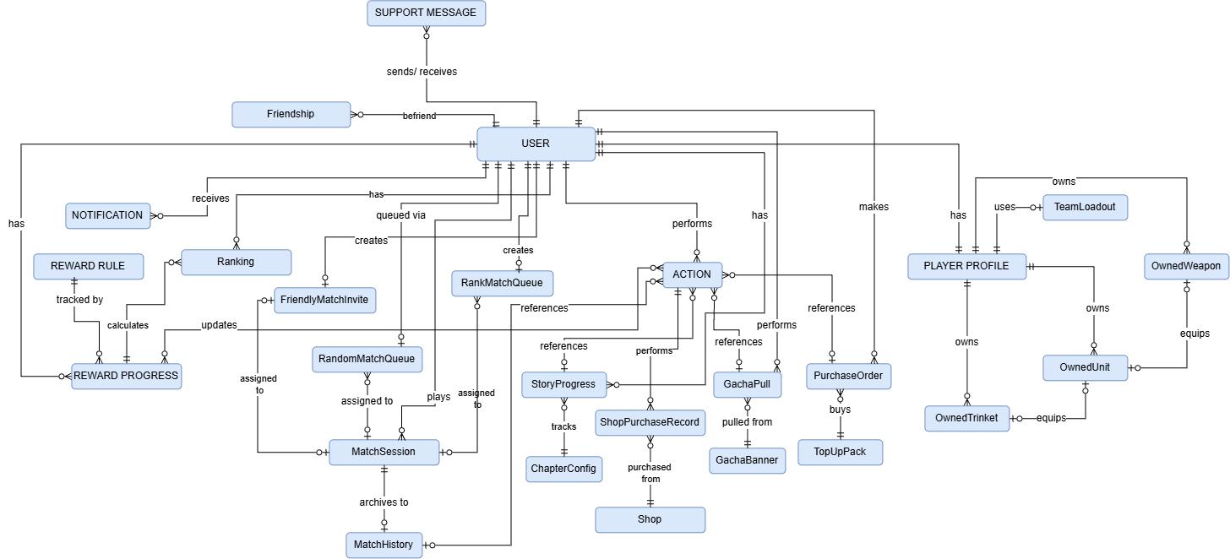
- Physical Diagram
Link
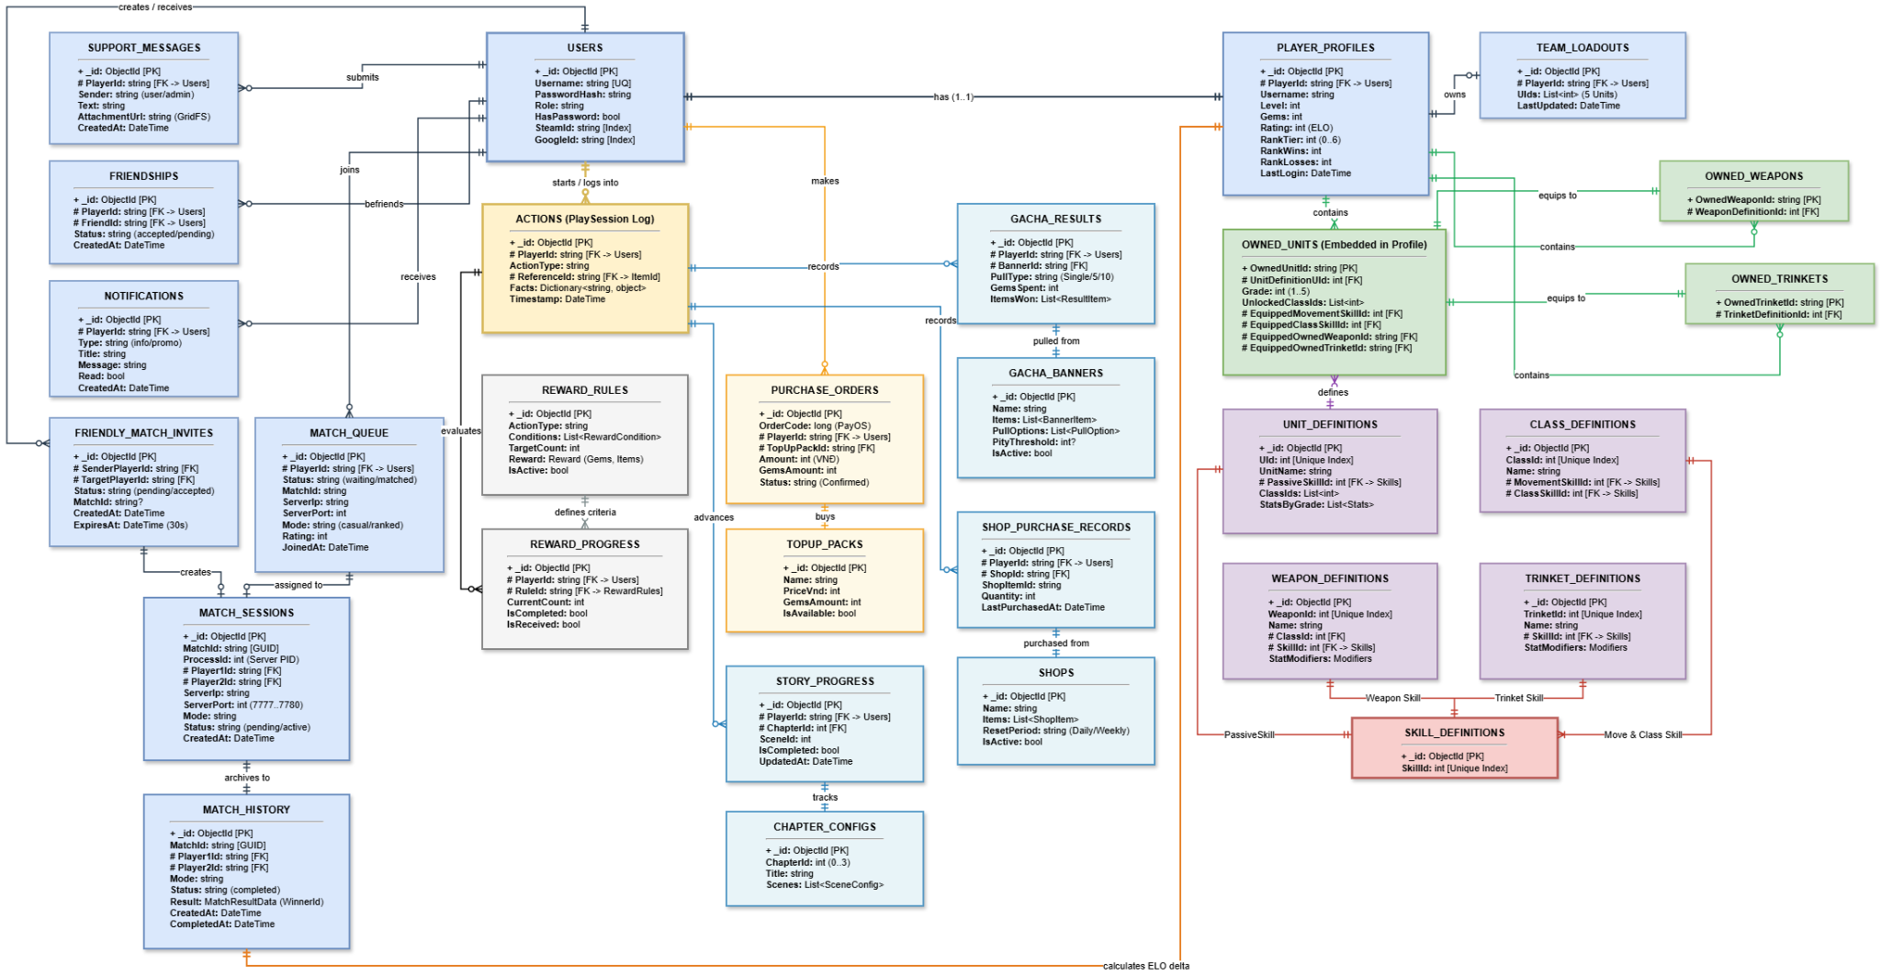

Entities Description
# | Entity | Description
1 | Users | Manages user account credentials, third-party login links (Steam, Google), and system access roles (Player, Admin, Moderator, Support).
2 | PlayerProfiles | Stores player profile details, including Commander level, experience, Gem balance, competitive rating, rank tier, win/loss records, and owned inventories (units, weapons, and trinkets).
3 | TeamLoadouts | Saves the player's active 5-unit combat formation for battle deployment.
4 | UnitDefinitions | Master catalog of character units, defining base attributes by grade (HP, SP, Speed, Damage), innate passive skills, and unlockable combat classes.
5 | ClassDefinitions | Master catalog of character classes (e.g., Swordsman, Archer), specifying class-exclusive movement skills and active combat abilities.
6 | WeaponDefinitions | Master catalog of weapons, detailing bonus stat attributes, class equip restrictions, and weapon-specific combat skills.
7 | TrinketDefinitions | Master catalog of accessories, defining supplementary stat boosts and attached support skills.
8 | SkillDefinitions | Centralized directory of all combat, movement, and support skills available across the game.
9 | Actions | Logs in-game player activities (such as Gacha summons, shop purchases, story clearances, and match completions) to evaluate and trigger quest rewards.
10 | MatchQueue | Manages the online matchmaking queue for Casual and Ranked modes, dynamically expanding the rating search range over time to pair players.
11 | FriendlyMatchInvites | Tracks real-time 1v1 friendly match invitations between friends, which automatically expire after 30 seconds.
12 | MatchSessions | Monitors ongoing real-time matches, tracking room status and server connection details for active battles.
13 | MatchHistory | Permanently records completed match outcomes, including the winner, match duration, total damage dealt, and rating adjustments.
14 | RewardRules | Defines quest and mission rules configured by administrators, specifying completion criteria, target milestones, and corresponding rewards.
15 | RewardProgress | Tracks individual player progress toward quests and missions, including current milestone counts, completion status, and reward claim status.
16 | GachaBanners | Configures summoning banners for units and weapons, specifying item pools, drop rates, summon costs, and guaranteed pity thresholds.
17 | GachaResults | Records the history of player Gacha summons, including obtained items, Gems spent, and bonus Gem compensation for duplicate items.
18 | Shops | Configures in-game store catalogs, defining items available for Gems, purchase limits, refresh cycles (Daily, Weekly, Lifetime), and sale durations.
19 | ShopPurchaseRecords | Tracks individual player purchase counts for store items to enforce buying limits across refresh cycles.
20 | TopUpPacks | Catalog of real-money Gem packages (in VND) available for purchase on the web portal and in-game store.
21 | PurchaseOrders | Manages real-money top-up transactions via VietQR/PayOS, tracking payment statuses (Pending, Confirmed, Cancelled) to automatically credit Gems upon confirmation.
22 | ChapterConfigs | Configures story campaign chapters, structuring narrative dialogues, cutscenes, combat encounters, and battle maps.
23 | StoryProgress | Tracks player progression through story chapters and scenes, allowing players to resume unfinished stages.
24 | Friendships | Manages social connections between players, including friend requests, acceptances, rejections, and blocked users.
25 | Notifications | Manages the player inbox for system announcements, maintenance alerts, friend notifications, and reward deliveries, along with read statuses.
26 | SupportMessages | Stores customer support tickets and conversation logs between players and support staff, including attached screenshots for issue resolution.

3.2 Authentication & New Player Onboarding Feature

3.2.1 Login & Account Authentication
Function trigger: Triggered automatically when the player launches the Pactkeeper Login screen or when staff access the Web Management Portal.
Function description:
- Actors: Player, Admin, Moderator, Technical Support, Google OAuth, Steam Auth.
- Purpose: Authenticates user identity, issues a role-scoped JWT session token, and initializes starter assets for newly registered accounts.
- Interface: Game Client Login Screen (Google Sign-In, Username/Password) and Web Portal Login.
- Data processing: When a player logs in with Google or Steam, the system confirms who they are. If it is their first time playing, the system creates a new account and gives them a starter pack: 5 Grade 1 units (Assassin, Tank, Warrior, Archer, Physician), 6 basic weapons (Dagger, Sword & Shield, Axe, Crossbow, Holy Book, Staff of the Druid), and 3 trinkets.
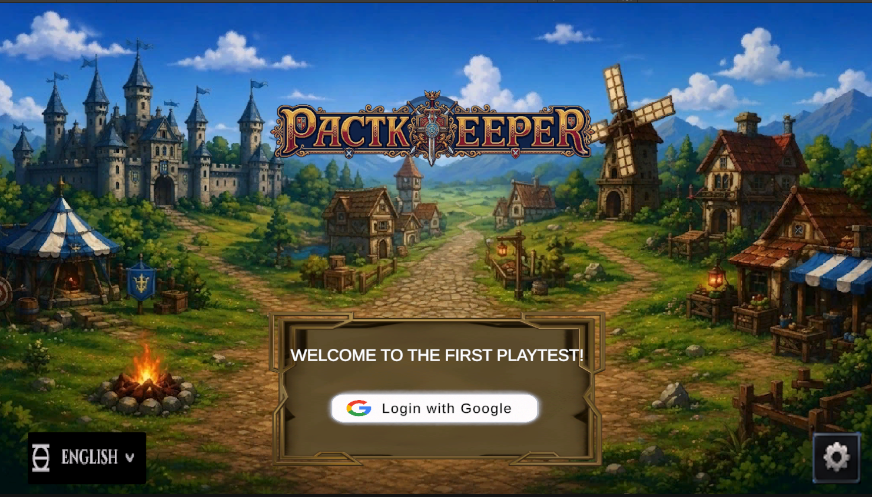
Function Details:
- Validation & Business Rules: The player must be signed in first, and their login must be confirmed as genuine. The system also checks the account status: Active, Suspended, or Banned.
- Normal case: If the login is valid, the player enters the game with their profile. If they have not finished the Prologue & Story & Tutorial, they are sent there first. Otherwise, they go straight to the Main Menu.
- Abnormal case: If the login is invalid, the system shows error AUTH_001. If the account is Suspended or Banned, the system shows a pop-up that explains the reason.

3.2.2 Prologue & Interactive Story Tutorial
Function trigger: Starts automatically after a player’s first login, or the player can open it manually from Main Menu → Story Chapter → Chapter 0.
Function description:
- Actors: Player, System.
- Purpose: Tells the story of the hero Varek and his mentor Reinhardt in the Divine Eye Realm. Through 3 short scenes (Scene 0.1 to 0.3), it teaches the player the core timeline mechanic called “The Eye”.
- Interface: Story prompts and highlights appear on top of the real battle screen (9x7 grid), so the player learns while looking at the actual game board.
- Data processing: The tutorial follows a prepared script made of simple steps: show text, ask the player to click a button or a grid cell, ask for a right-click, move on automatically, or finish and exit. Each step goes through the same 5 stages: get ready, find the target, show the instruction, wait for the player’s action, then move to the next step.
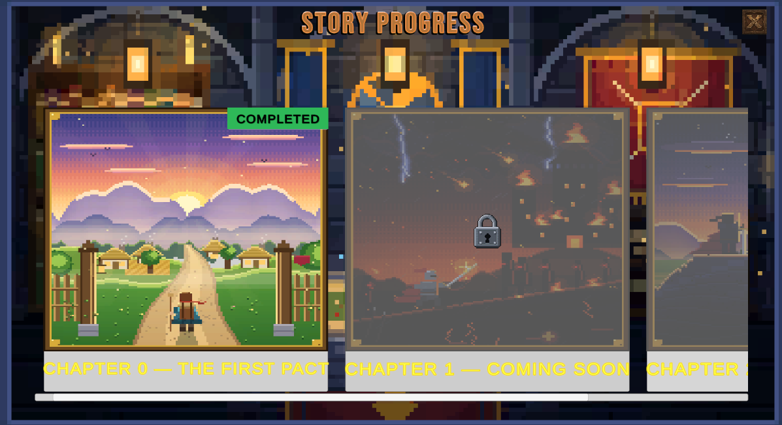
Function details:
- Scene 0.1 (The Patience Lesson): The player learns how to read the queue that shows whose turn is next, then picks the Assassin and moves it in an L-shape (Sneaky Steps). After confirming the move, the player learns that waiting for 5 idle instants recovers 1 SP. The player also learns to right-click a weapon to see its skills.
- Scene 0.2 (The Vanguard’s Strike): The battle continues from the previous scene. The player learns the difference between instant actions (Move) and non-instant actions (Attack). The player moves the Warrior first to activate the Assault passive (double damage), then attacks with the Axe.
- Scene 0.3 (Breaking the Limit): The enemy has 2 out of 3 HP left, and the Assassin has 1 SP. The player uses Limit Break (costs 1 SP, gives +15 Speed and +1 Attack Multiplier), then attacks from above to trigger Ambush (double damage) and defeat the enemy.
- Completion & Abnormal case:
  - Completion: When the tutorial ends, the system saves the player’s progress and rewards them with 200 Gems.
  - Abnormal case: If the player disconnects in the middle of a lesson, the system restores their progress when they return. The current scene restarts from the beginning (Instant 0).

3.3 Armory, Inventory & Team Formation Feature
3.3.1 Configure Unit & Armory Management
Function trigger: The player opens it from Main Menu to Inventory or Profile Tab, then selects a unit.
Function description:
- Actors: Player.
- Purpose: Lets the player view a unit’s stats (HP, Speed, Max SP, and Passive for Grade 1 and Grade 2) and choose what the unit uses: unlocked Movement Skills, Class Weapons, Class Skills, and Trinkets that any unit can equip.
- Interface: A Profile & Armory screen that shows the 6 classes (Assassin, Tank, Warrior, Archer, Physician, Druid), 12 weapons, and 8 trinkets.
- Data processing: The system loads the items the player owns and the game’s official information about each unit, weapon, trinket, and skill. When the player saves, the unit’s new setup is stored in their account.
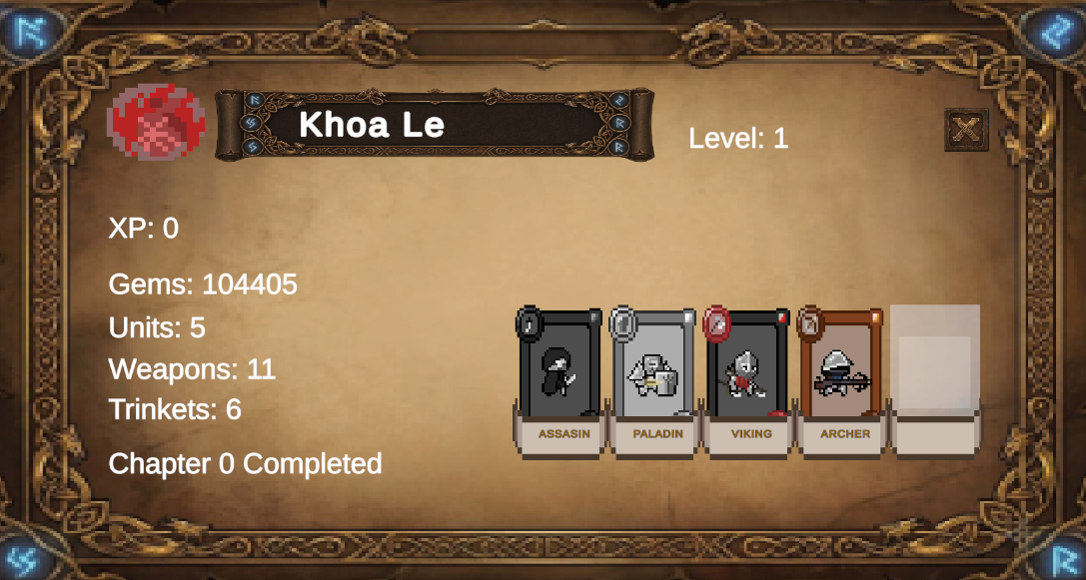
Function Details:
- Validation & Business Rules: Each class can only use its own type of weapon. The Assassin uses Daggers, the Tank uses Sword & Shield or Kite Shield, the Warrior uses Axes, the Archer uses Bows, the Physician uses Books, and the Druid uses Staves. Grade 2 units unlock extra slots for their class. Trinkets (Monocle, Spyglass, Boots, Heels) can be used by any class.
- Normal case: If the player picks valid equipment, the unit’s loadout is updated and a success message appears.
- Abnormal case: If the player tries to equip a weapon that does not match the unit’s class, the system shows an error message and the loadout stays the same.
3.3.2 Manage Team Formation & Pre-Match Preparation
Function trigger: The player opens it from Main Menu → Manage Team Formation, or it opens automatically when a match is found.
Function description:
- Actors: Player, Game Server.
- Purpose: Lets the player choose up to 5 of their units and place them on their starting cells on the 9x7 grid before the battle begins.
- Interface: A formation screen with the 9x7 grid, a list of the player’s units on the side, and a 120-second countdown timer.
- Data processing: The system saves the player’s default 5-unit team. Before a match, each player has 120 seconds to place their units, and they cannot see the opponent’s setup.
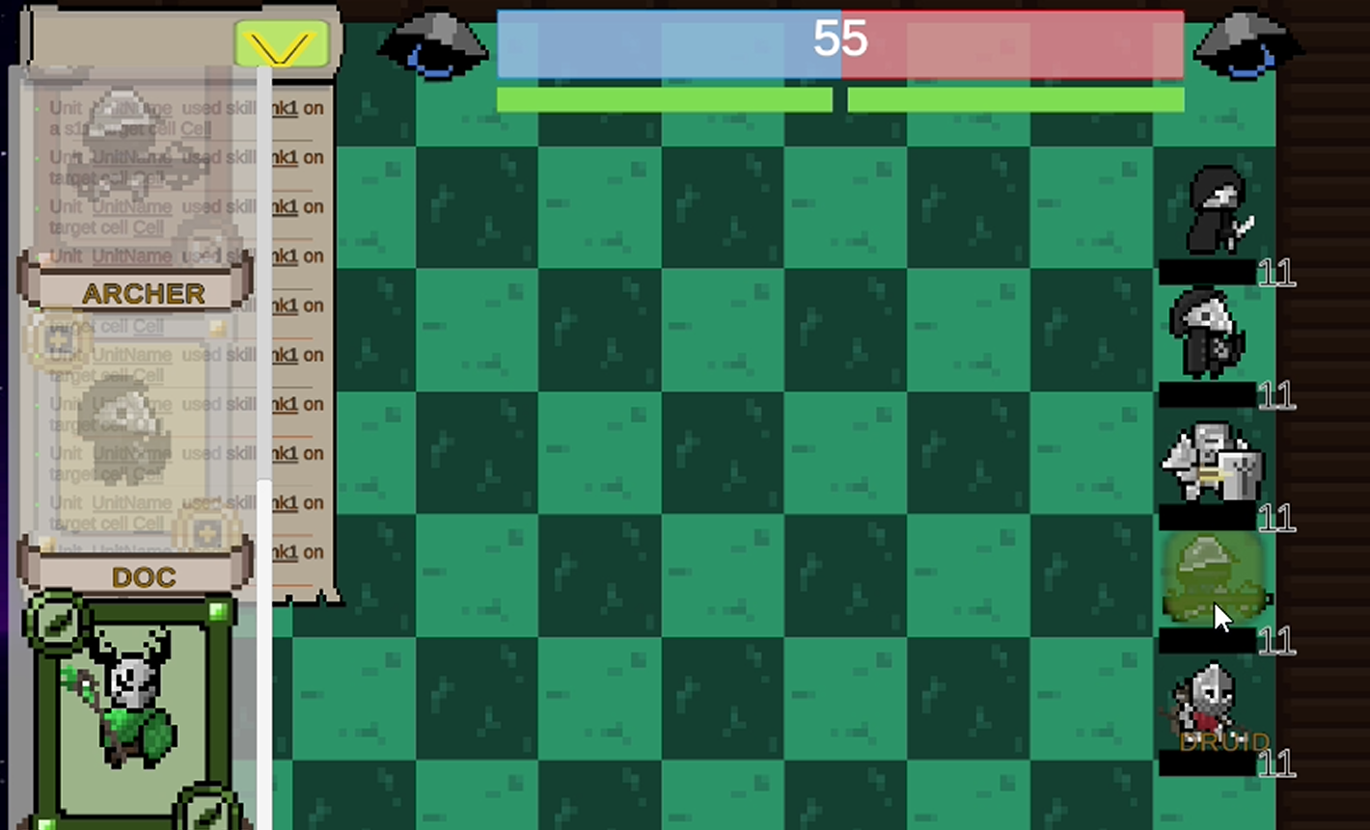
Function details:
- Validation & Business Rules: A team should have 1 to 5 units that the player owns. Unit stats are calculated fresh when the match starts, based on the unit’s current setup.
- Normal case: When both players confirm their formations within 120 seconds, the battle starts right away.
- Abnormal case: If the player tries to save a team with no units, the system shows error. If the 120-second timer runs out, the system automatically confirms the player’s current team placement, or their default team if they have not placed anyone yet.

3.4 Gacha, Shop & Payment Feature
3.4.1 Gacha Summoning
Function trigger: The player opens it from Main Menu → Gacha, then clicks Pull 1 (160 Gems) or Pull 10 (1,500 Gems).
Function description:
- Actors: Player.
- Purpose: Lets the player spend Gems to get random rewards from the current banner. Rewards include Units (top tier), Weapons or Trinkets with bonus stats (mid tier), basic Weapons or Trinkets (low tier), and bonus Gems.
- Interface: A summon banner screen with a Rates Detail button, a Pull 1 button (160 Gems), and a Pull 10 button (1,500 Gems). After pulling, the player sees a reveal screen with the result cards.
- Data processing: The system first checks that the player has enough Gems. It then picks the rewards randomly on the server, using the drop rates shown below. If the player gets a duplicate, it is converted into Gems or used to upgrade a unit to Grade 2. Finally, the system saves the results and checks if the player has earned any extra rewards.
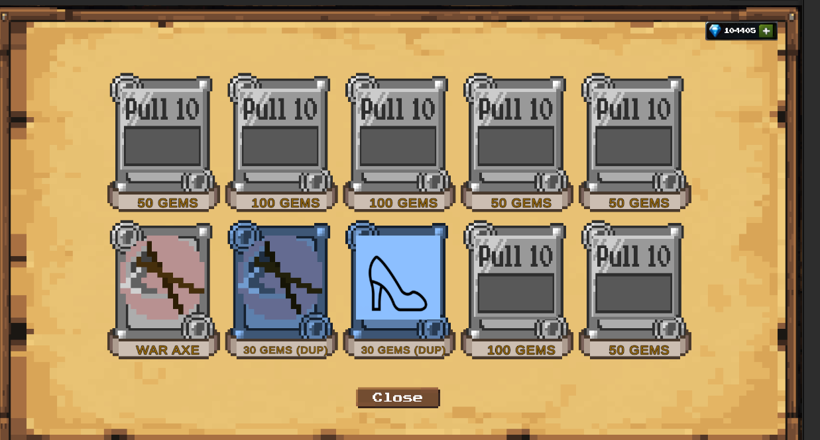
Function details:
- Validation & Business Rules: Gems are always deducted exactly as priced (BR-06). If the player pulls an item they already own, it is turned into Gems: 30 Gems for a Tier 1 item, 80 Gems for a Tier 2 item. For a Tier 3 duplicate (a Unit), the player gets either 150 Gems or an upgrade to Grade 2. The system also counts the player’s pulls and tracks a “pity” counter that reaches its limit at 80 pulls.
- Normal case: If the player has enough Gems, the system takes 160 Gems (Pull 1) or 1,500 Gems (Pull 10), gives the rewards (or Gems for duplicates), and shows the card reveal screen.
- Abnormal case: If the player does not have enough Gems, the pull is cancelled and the player is invited to go to the Top-up Center.
3.4.2 In-Game Shop
Function trigger: The player opens it from Main Menu to Shop, then selects the Shop tab.
Function description:
- Actors: Player.
- Purpose: Lets the player buy items directly with Gems, including weapons, trinkets, and supplies. The items change over time, and each item has a purchase limit (daily, weekly, or lifetime).
- Interface: A shop screen that lists the available items (for example, “It’s raining gems” and “Daily Adventurer Bazaar”). Each item shows how many the player can still buy (such as “1 left” or “3 left”), its Gem price, and a countdown to the next reset (for example, “Resets: Daily at 00:00 UTC”).
- Data processing: The system shows the items currently on sale and how many of each the player has already bought. When the player buys an item, the system takes the Gems, adds the item to the player’s inventory, updates the purchase count, and records the action.
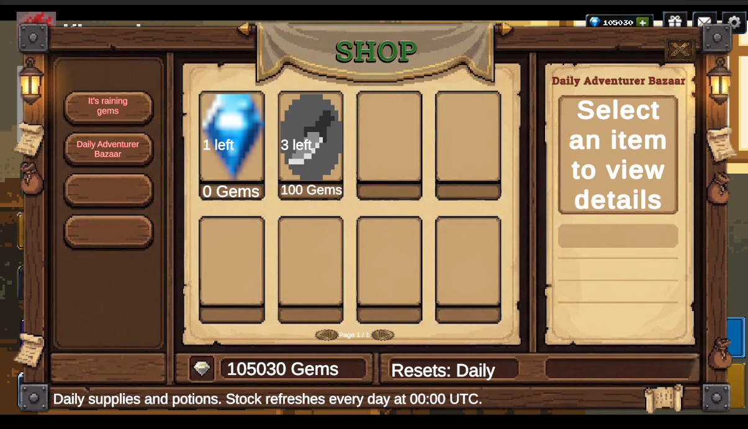
Function Details:
- Normal case: If the item is in stock and the player has enough Gems, the item is added to the player’s inventory and the remaining stock goes down by 1.
- Abnormal case: If the purchase limit is reached (“0 left”) or the player does not have enough Gems, the Buy button is disabled or an error message appears.
3.4.3 Real-Money Gem Top-Up
Function trigger: The player opens it from Main Menu by clicking the “+” icon next to Gems, or the TopUp Web URL button in the Pactkeeper TopUp Center window.
Function description:
- Actors: Player, PayOS Payment Gateway.
- Purpose: Lets the player buy Gem packs by bank transfer using a VietQR code. The packs are:
- Gem Starter: 20,000 VND for 200 Gems
- Assassin Bundle: 25,000 VND for 50 Gems and a Dagger
- Gem Pouch: 50,000 VND for 550 Gems
- Gem Chest: 100,000 VND for 1,200 Gems
- Full Arsenal: 200,000 VND for 1,000 Gems and 6 starter weapons
- Interface: A TopUp Center window in the game, and a separate top-up website that shows a VietQR code for the payment.
- Data processing: When the player picks a pack, the system creates a pending order with a unique order code. After the player scans the QR code and pays, PayOS notifies the system. The system checks that the notification is genuine, confirms the order, adds the Gems or items to the player’s account, and records the purchase.
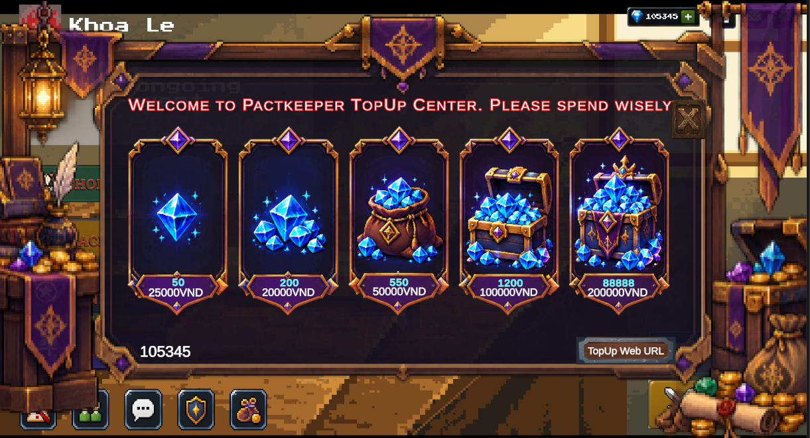

Function Details:
- Validation & Business Rules: The payment notification must be verified as genuine, and each order can only be fulfilled once, so the player never receives a pack twice.
- Normal case: When the payment is confirmed, the Gems are added right away and the Gem counter in the game updates.
- Abnormal case: If the player cancels the payment or the QR code expires, the order is marked as Cancelled and no Gems are added.

3.5 Matchmaking & Authoritative Tactical Combat Feature
3.5.1 Matchmaking Queue
Function trigger: The player opens it from Main Menu to Matchmaking Queue (Ranked or Unranked), or from Friend List to Invite to Match.
Function description:
- Actors: Player, System.
- Purpose: Matches two players for a 1v1 battle. Ranked matches pair players with similar ELO ratings. Unranked uses an open queue. Friendly matches connect two friends through an invite that lasts 30 seconds. Once two players are matched, the system creates a private battle room for them.
- Interface: A queue timer screen and a Friendly Invite pop-up.
- Data processing: The player joins the queue. In Ranked, everyone starts at 1000 ELO. The system first looks for an opponent within ±100 ELO, then widens the range by ±50 every 10 seconds, up to ±400. If no opponent is found after 60 seconds, the player is matched with a Bot. When a match is made, the system creates the battle room and sends both players the connection details.
Function Details:
- Validation & Business Rules: A player can only be in one queue at a time (BR-07). The system alone decides and starts the match (BR-08). The ELO range widens over time, and a Bot joins after 60 seconds (BR-12).
- Normal case: When a match is found, the player sees MATCH_002 and both players are connected to the battle.
- Abnormal case: If the player cancels before being matched, they leave the queue and see MATCH_003. If a friend does not respond to the invite within 30 seconds, the invite expires automatically.
3.5.2 Authoritative Tactical Combat
Function trigger: Starts automatically after Formation Preparation ends, or when the player enters a Story battle.
Function description:
- Actors: Player, Game Server.
- Purpose: Runs a turn-based tactical battle on a 9x7 grid. Time moves in small steps called “instants” (0.3 seconds each), up to 150 instants per match.
- Interface: The battle screen has four areas:
- Top: The queue showing whose turn is next (“The Eye”).
- Center: The 9x7 grid. Blue cells show where a unit can move, red cells show attack range, and orange cells show extended range from buffs.
- Bottom left: The unit panel with HP (1–10), SP (1–6), and icons for Move, Weapon, Class Skill, and Trinket.
- Bottom right: The Confirm, Wait, and Undo buttons, plus the instant counter.
- Data processing:
- Timeline: Every unit has a countdown that goes down with each instant. Faster units count down quicker, so they act more often. When a unit’s countdown reaches zero, the game pauses for that unit’s turn.
- Commands: Players left-click to select and give commands, and right-click to inspect. Instant skills (such as Move, Limit Break, Guard, Push, Focused Aim, and Trinket buffs) take effect immediately. Half-instant skills (Triage, Pull, Holy Book Heal) also take effect immediately, but the unit cannot do anything else during that turn. Normal weapon attacks wait and all take effect together at the end of the turn.
- Damage: The server calculates damage from the weapon’s base damage, then applies bonuses (such as passives) and the target’s damage reduction. Damage is always at least 1 and never above the damage cap.
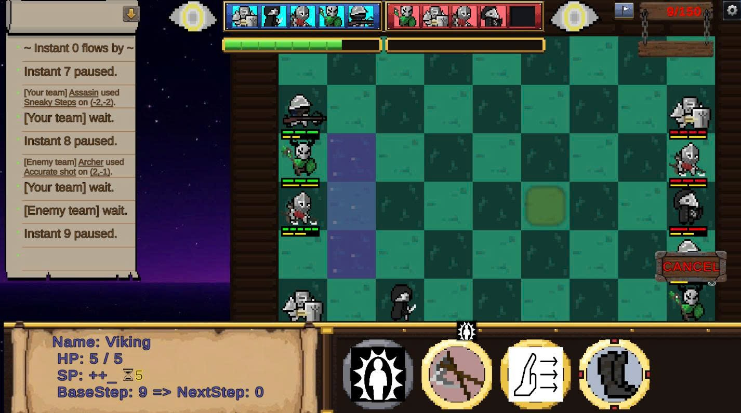
Function Details:
- Validation & Business Rules:
- The server is the only source of truth for the battle.
- The match ends after 150 instants, when one team is wiped out, or after 3 passes in a row.
- Each ready unit gets 15 seconds to act, up to 75 seconds per turn, plus a 200-second overtime bank. If a player times out 3 times in a row, they lose for being AFK. A disconnected player has 60 seconds to reconnect.
3.5.3 Post-Match Resolution, ELO Ranking & Match History
Function trigger: Starts automatically when the server detects that the match has ended.
Function description:
- Actors: Game Server, Backend System, Player.
- Purpose: Decides the winner, updates ELO and ranking tier, saves the match record, and gives milestone rewards. The ranking tiers are:
- Beginner: 0–1099
- Master: 1100–1299
- Captain: 1300–1499
- Pactkeeper: 1500–1699
- Pactmaker: 1700–1899
- Pactlord: 1900+
- Data processing: The game server sends the result to the backend. The backend saves the match to the player’s history, updates their ELO and rank, records the result as a player action, and checks whether any rewards were earned.

3.6 Missions, Rewards, Social & Live Support
3.6.1 Rule-Based Quests & Milestone Rewards
Function trigger: Runs automatically after any player action (match result, gacha pull, purchase, story progress). The player views quests from Main Menu to Quest List.
Function description: The system checks each player action against the reward rules, updates the player’s progress, and lets the player claim rewards. Examples:
- Win 3 matches: 500 Gems
- Win with 3 or more units alive: Sharp Dagger
- Win 10 matches: Druid unit
- Pull 5 times: 300 Gems
- Pull a Tier 3 unit: 1,000 Gems
- Spend 1,000 Gems: Steel Heels
- Complete Chapter 0: 200 Gems
3.6.2 Friends, Mailbox & Support Chat
Function trigger: The player selects an icon on the social bar in the Main Menu.
Function description: Manages these features:
- Friendships between players (both sides must accept).
- Real-time friendly match invites.
- System and reward notifications.
- Live two-way chat between players and support staff, including screenshot attachments.
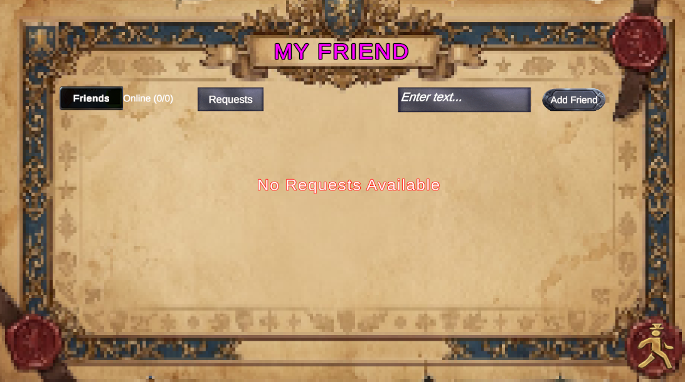

3.7 Web Management Portals
3.7.1 Admin Portal: Lets Admins track the number of players online and active each day, view payment revenue, look up, ban, or unban player accounts, and check top-up transactions.
3.7.2 Moderator Portal: Lets Moderators review the turn-by-turn log of past matches, set up summon banners and shop rotations, edit unit, weapon, and skill details, and create quest rules without writing code.
3.7.3 Technical Support Portal: Lets Tech Support watch server health (CPU and memory), view or stop running battle rooms, check error logs, and reply to player support tickets in real time.

4. Non-Functional Requirements
This section specifies the non-functional requirements (NFRs) for the Pactkeeper Tactical Strategy Role-Playing Game (SRPG) system, encompassing the Unity 6.x Game Client, the dedicated headless game server cluster, the ASP.NET Core backend Web API, and the Web Management Portals (Admin_Pactkeeper). These requirements establish the operational criteria, communication protocols, performance standards, quality attributes, and security constraints required to ensure a responsive, highly reliable, and competitive online gaming environment.

4.1 External Interfaces
The Pactkeeper system communicates across multiple distinct software, hardware, and network interfaces to facilitate low-latency tactical combat, secure account management, and real-time operational administration:
• User Interfaces (UI): The system delivers two primary graphical user interface tiers: (1) The Game Client built with Unity 6.x UI and TextMeshPro, dynamically adapting to widescreen 16:9 aspect ratios (1920x1080 Full HD baseline with 2K/4K scaling). It features an integrated Charge Time (CT) timeline progression bar, dynamic tile grid highlight shaders (blue for valid movement, red for attack radius, orange for AoE abilities), unit HP/Energy gauges, and runtime bilingual localization (English/Vietnamese). (2) The Web Management Portal (Admin_Pactkeeper) built with React 18, Vite, and Tailwind CSS, providing responsive, role-tailored administrative workspaces, telemetry widgets, searchable audit tables, and configuration modals.
• Hardware Interfaces: The Unity Game Client interfaces with standard PC peripherals, utilizing mouse input (primary click for grid tile navigation and ability selection, right-click/ESC for action cancellation) and keyboard hotkeys (keys 1-5 for skill slots, Space/Enter for confirmation). Graphical rendering requires a GPU supporting DirectX 11/12 or Vulkan. The server infrastructure interfaces with high-bandwidth Virtual Private Server (VPS) hardware with multi-core x86_64 CPUs and high-throughput network interface cards (NICs) capable of sustaining heavy concurrent UDP packet streams.
• Software Interfaces: Operating systems include Microsoft Windows 10/11 (64-bit) for client workstations and Linux Ubuntu 22.04 LTS for backend host servers. The backend runtime is built on ASP.NET Core 8.0 Web API (GameInventoryApi). Primary data persistence is provided by MongoDB 7.0+ for player accounts, inventories, summon pools, and match history. Real-time multiplayer synchronization is powered by Unity Netcode for GameObjects (NGO) operating on top of Unity Transport Protocol (UTP).
• Communications Interfaces: The system employs three specialized communication layers: (1) RESTful HTTP/HTTPS over TLS 1.3 with JSON payloads and Bearer JWT authorization headers for account management, inventory mutations, and Web Portal administration (documented via OpenAPI 3.0 / Swagger). (2) WebSocket / SignalR for real-time bidirectional support chat (Player Chat Room) and instant system notifications. (3) UDP Sockets via Unity Transport Protocol on dedicated ports (7777–7800) for high-frequency, authoritative turn-based multiplayer combat state synchronization.
• Third-Party Service Interfaces: The application integrates with: (1) Google OAuth 2.0 (accounts.google.com) for unified single sign-on (SSO) authentication across players and administrative staff. (2) Steamworks.NET for Steam platform authentication and PC entitlement verification. (3) PayOS Payment Gateway (api.payos.vn) for generating dynamic VietQR codes for banking payments and receiving asynchronous webhook notifications secured via HMAC-SHA256 signature verification.

4.2 Quality Attributes
The quality attributes specify the measurable characteristics and architectural constraints that guarantee software quality, system resilience, and high satisfaction for players and operational personnel.

4.2.1 Usability
• Intuitive Navigation & Ergonomics: The application follows a standardized hierarchical menu structure (Login → Main Menu Hub → Sub-features). All primary gameplay functions (Formation, Gacha, Inventory, Story, Matchmaking) are accessible within two clicks from the Main Menu.
• Combat Ergonomics & Visual Cues: The tactical battlefield visualizes all critical parameters transparently: a dynamic timeline bar previews forthcoming turn order based on Charge Time (CT); grid tiles display color-coded movement and targeting areas; and damage/healing forecasts are previewed before confirming ability execution.
• Seamless Bilingual Localization: The system supports full runtime localization in English and Vietnamese across all UI elements, item names, and visual novel dialogues via Unity Localization, instantly switchable in the Profile settings without requiring a client restart.
• Onboarding & Learnability: First-time players undergo an interactive Prologue and tutorial battle covering tactical movement, CT accumulation, ability casting, and turn resolution, enabling an inexperienced user to master core mechanics within 5–7 minutes.
• Contextual Feedback & Form Validation: Input errors (e.g., duplicate nickname, invalid formation) trigger immediate, descriptive feedback via non-blocking toast notifications or colored inline messages rather than obscure error codes.

4.2.2 Reliability
Server-Authoritative Anti-Cheat Architecture: To guarantee competitive integrity, 100% of combat logic—including unit stats, grid positions, movement validity, skill ranges, damage calculations, and victory/defeat resolution—is calculated authoritatively on the dedicated server. Client manipulation of local memory cannot alter combat outcomes.
• System Availability: The system targets a monthly service availability of at least 99.5% uptime during operational hours (equivalent to less than 3.65 hours of unscheduled downtime per month), excluding pre-announced maintenance periods.
• Mean Time Between Failures (MTBF): The backend API and MatchQueue coordination services are engineered for an MTBF of at least 720 operating hours (30 consecutive days) without critical service interruption or fatal memory leakage.
• Mean Time To Repair (MTTR): In the event of an unhandled host process failure, automated systemd daemon supervisors and Docker health monitors ensure service recovery and restart within an MTTR of less than 30 minutes.
• Network Fault Tolerance & Reconnection: If a player's network connection drops during an active PvP match, the match server preserves the player's session for a 60-second grace window. The client automatically attempts reconnection via GET /api/match/current upon returning to Main Menu.
• Data Integrity & Multi-Document Atomicity: Financial transactions and player asset mutations (Gem purchases, gacha rolls, equipment upgrades) employ MongoDB multi-document ACID transactions with idempotent processing to eliminate currency duplication or partial state corruption.
• Defect Density Standard: The release criteria enforce zero critical or showstopper defects (crashes, billing loss, data corruption) and a defect density of fewer than 0.5 major defects per thousand lines of code (KLOC).

4.2.3 Performance
• Low-Latency Combat Synchronization: Round-Trip Time (RTT) between game client and dedicated match server is maintained below 80ms for domestic connections (Vietnam) and below 150ms for regional connections over UDP sockets.
• API Response Latencies: Under standard operational load, 95% of read-only REST API requests (profile, inventory, quests, leaderboards) respond in less than 200ms; 99% of state-mutating transactional requests (gacha roll, formation save, upgrade) respond in less than 500ms.
• Matchmaking Efficiency: The MatchQueue matchmaking service evaluates and pairs eligible players in 3-second polling cycles. Average matchmaking wait time is under 15 seconds during active peak periods.
• Turn Pacing & Match Throughput: Unit turn decision window is capped at 15 seconds per unit (actWaitWindowPerInstantPerReadyUnit = 15s), backed by a 200-second team overtime reserve. Visual pacing between instants is set to 0.3s (instantDuration = 0.3s), and matches are strictly bounded to 150 instants (maxInstant = 150), preventing stalled games.
• System Throughput & Scalability: The ASP.NET Core backend supports at least 500 concurrent HTTP requests per second per node. The dedicated server cluster dynamically spawns and manages at least 500 concurrent headless match instances (1,000+ simultaneous players) across Linux VPS nodes.
• Client Resource Utilization: The client maintains a stable frame rate of at least 60 FPS on recommended PC configurations at 1080p resolution. Client RAM footprint remains below 2.5 GB. Each headless match server process on Linux consumes less than 150 MB RAM and less than 10% CPU of a modern single core.

5. Requirement Appendix
This appendix provides supplementary requirement artifacts, including the formal system Business Rules, Common Requirements across all system modules, the complete Application Messages List, and Other Environmental Requirements governing hardware, software, and network prerequisites.

5.1 Business Rules
The following table defines the authoritative business rules (BR-01 through BR-16) that govern game mechanics, security validation, combat resolution, and financial transactions across the Pactkeeper SRPG platform:
ID | Rule Definition
BR-01 | Authentication Prerequisite: A user must successfully authenticate (UC01) and obtain a valid, cryptographically signed JWT bearer token before accessing any meta-game features, inventory assets, or matchmaking queues.
BR-02 | Session & Token Rejection: Any incoming API request or dedicated game server connection attempt with an expired, missing, or malformed JWT token must be immediately rejected with HTTP 401 Unauthorized or Netcode Connection Approval Rejection.
BR-03 | Team Formation Composition: A deployed combat lineup must consist of at least 1 unit and a maximum of 5 units deployed across available grid deployment tiles. Only heroes currently owned in the player's account roster can be assigned to formation slots.
BR-04 | Class-Restricted Weaponry: Weapons may only be equipped by units matching the weapon's designated classId (e.g., Swords are restricted to Warriors, Staves to Mages, Bows to Archers). Trinkets and accessories have universal class usability.
BR-05 | Authoritative Combat Stat Computation: Unit combat attributes (HP, ATK, DEF, SPD, Mana) are calculated dynamically at match initialization from base character grade + equipped weapon/trinket stats. Combat stats are runtime values and are never stored as mutable properties in the database.
BR-06 | Gacha Summoning & Pity Rules: Single and 10x summon pulls strictly deduct premium Gems based on banner configuration. Pulling duplicate characters automatically converts the hero into breakthrough materials and awards pity tokens per the published pity threshold rate.
BR-07 | Single Queue Exclusivity: A player UID can participate in only one matchmaking queue at any given time. Submitting a new queue request while already queued in another game mode is rejected.
BR-08 | Authoritative Match Dispatching: Upon pairing two compatible players, the backend Matchmaking service generates a unique Match ID, dynamically allocates a dedicated headless game server instance (IP address and UDP port 7777+), and transmits connection coordinates to both matched clients.
BR-09 | Server Authoritative Source of Truth: The dedicated game server is the sole authoritative source of truth for grid tile positioning, Charge Time (CT) timeline progression, ability resolution, and unit HP calculations. Client-side state displays are strictly predictive and reconciling.
BR-10 | Match Termination Triggers: A tactical combat match terminates if and only if one of the following conditions is satisfied: (a) all units of one team are eliminated, (b) both teams consecutively pass their turns for 3 consecutive paused instants, or (c) the maximum timeline limit of 150 instants (maxInstant) is reached.

5.2 Common Requirements
Common requirements define global architectural constraints and behavioral rules enforced across all system components:
• Data Formatting & Standardization: All system timestamps are recorded and transmitted in ISO 8601 UTC format (YYYY-MM-DDTHH:mm:ss.sssZ). In-game soft currencies (Gold) and premium currencies (Gems) are stored as non-negative 64-bit integers. Real-world monetary values are stored in VND (Vietnamese Dong) with appropriate thousand separators. All administrative and player search queries enforce standard pagination with a default page size of 20 items (maximum 100 items per request).
• Session Lifecycle & Authentication: The client performs silent JWT validation on every API interaction. If a session token expires during active play, the client prompts the user to re-authenticate without terminating uncommitted local configurations where possible. Concurrent logins using the same account revoke earlier session tokens immediately.
• Network Resilience & Latency Handling: The game client continuously tracks round-trip ping latency to dedicated match servers, rendering a real-time HUD indicator color-coded by quality (green: <80ms, yellow: 80-150ms, red: >150ms). Non-critical HTTP network failures trigger automated exponential backoff retries (maximum 3 attempts) before displaying user alerts.
• Input Validation & Data Sanitization: All client-side inputs (player nicknames, chat messages, search parameters) undergo strict type and length validation. An automated profanity filtering library masks offensive terms in player display names and public chat rooms to maintain a welcoming community environment.
• Administrative Audit Logging: All administrative actions executed via the Web Management Portal (account suspensions, manual currency grants, gacha rate updates, story modifications, headless server process terminations) are immutably logged with administrative staff ID, timestamp, target entity, and justification rationale.

5.3 Application Messages List
The following table provides the standardized inventory of system notification messages, modal dialogues, and alert banners displayed across the Game Client and Web Management Portals:
# | Message code | Message Type | Context | Content
1 | AUTH_001 | In-line Alert | Failed credential authentication during portal/client login | Invalid username or password. Please verify your credentials and try again.
2 | AUTH_002 | Modal Dialog | Session expiration during active client operation | Your session has expired. Please log in again to continue.
3 | AUTH_003 | Modal Dialog | Account suspension/ban encountered at login | This account has been suspended due to violations of our Terms of Service. Reason: {ban_reason}. Contact support for inquiries.
4 | FORM_001 | Toast Alert | Player attempts to save an empty combat formation | Team formation must contain at least 1 deployed unit before saving.
5 | FORM_002 | Toast Alert | Player attempts to equip class-incompatible weapon | Incompatible equipment: {item_name} cannot be equipped by {unit_class} class (BR-04).
6 | FORM_003 | Toast Alert | Successful team formation update | Team formation updated and synchronized successfully.
7 | MATCH_001 | Toast Alert | Player initiates matchmaking search | Enqueued for matchmaking. Searching for suitable opponent...
8 | MATCH_002 | Modal Dialog | Matchmaking finds opponent and allocates server node | Opponent found! Preparing tactical battlefield. Connecting to dedicated server...
9 | MATCH_003 | Toast Alert | Player manually cancels active matchmaking search | Matchmaking queue cancelled.

5.4 Other Requirements
This subsection outlines the minimum and recommended operational prerequisites across hardware, software platforms, and network infrastructure:
• Client Hardware Specifications: Minimum: Intel Core i3-8100 / AMD Ryzen 3 2200G (4 cores @ 3.5 GHz), 4 GB DDR4 RAM, Intel UHD Graphics 630 / NVIDIA GeForce GTX 750 Ti (2 GB VRAM, DirectX 11), 2 GB free disk storage. Recommended: Intel Core i5-10400 / AMD Ryzen 5 3600 (6 cores @ 4.0 GHz), 8 GB DDR4 RAM, NVIDIA GeForce GTX 1050 Ti / AMD Radeon RX 560 (4 GB VRAM), 5 GB high-speed SSD storage.
• Server Host Hardware Specifications (Linux VPS): Minimum Host: 2 vCPU, 4 GB RAM, 50 GB NVMe SSD, 100 Mbps network bandwidth. Production Dedicated Cluster: 4–8 vCPU, 16 GB RAM, 100 GB NVMe SSD, 1 Gbps dedicated network bandwidth (supporting up to 50 concurrent headless match instances per host).
• Software & Platform Dependencies: Client: Microsoft Windows 10 (64-bit v1909+) or Windows 11; DirectX End-User Runtimes (June 2010); Microsoft Visual C++ Redistributable 2015–2022. Web Management Portal: Google Chrome 110+, Microsoft Edge 110+, or Mozilla Firefox 115+ (with JavaScript and WebSockets enabled). Server: Ubuntu Server 22.04 LTS (x86_64); .NET 8.0 Runtime; MongoDB Server 7.0+; Docker Engine 24.0+; Nginx 1.22+ as reverse proxy and SSL terminator.
• Network & Firewall Configuration: Client Network: Minimum 2 Mbps download / 1 Mbps upload broadband connection; latency < 100ms and packet loss < 1% to game servers; open outbound TCP ports 80/443 (HTTP/HTTPS) and outbound UDP ports 7777–7800. Server Network: Inbound TCP ports 80/443 open for web traffic; inbound UDP port range 7777–7800 exposed for dedicated headless Netcode match processes.

